# **Terminologies**

1. Project team: Whether from the customer or a solution integrator, the team is responsible for the migration.
2. Business users: Individuals or Teams who are subject matter experts for the respective business.
3. Third-party applications: Business applications are integrated with the website.
4. Technical Solutions Organisation (TSO): Technical solutions division of Contentstack focused on customer enablement.
5. CMS: All legacy Content Management Systems, collectively.
6. Migration framework: A set of TSO-supported and documented tools, scripts, and migration procedures. Several legacy CMS platforms are currently supported.
7. In addition, content transformation and content import from JSON file formats into the Contentstack DXP system are available. The framework provides wider guidelines that can be customized according to the customer’s individual dataset.

# 

# **Discovery process**

The project team must determine the following as part of the discovery process.

1. **The goal:**
   1. **Redesign or Replatform:** Determine if the site is getting redesigned.
      1. A redesign will typically take longer than a platform due to additional processes involved in implementing the new designs and approaches.
   2. **Current Infrastructure:** Determine if the current CMS is an On-Premise version or a Cloud version. Refer to the current architecture diagram and verify accuracy.
      1. Identify the gaps in the current architecture diagram that will be fixed in the future state.
   3. **Source of truth:** Is the current CMS the Source of truth for the data? If not, seek an architecture diagram. In such cases, data will always be converted using a middleware that is connected to the current CMS. Refer to the current architecture diagram and verify accuracy.
      1. Identify the gaps in the current architecture diagram.
      2. Fix any gaps if the same architecture will be retained in the future.
2. **Content Audit:** Legacy content has to be audited to ensure only relevant content is migrated to Contentstack. The following is the outcome of the exercise:
   1. The list of Pages v/s the Sitemap has to be checked. Any standalone pages have to be reviewed for migrations
   2. Identify content that is irrelevant and needs to be descoped from the migration.
   3. Identify content that needs to be changed or updated. Content authors should curate the content before migrations.
   4. Identify content to be migrated as is.
3. **Technology stack:** The project team to select the appropriate Tech stack based on which the site will be built.
4. **Deadlines:** Determine crucial dates, milestones, and deliverables for the project.

# **Planning**

The following tasks are essential during the planning stage.

1. **Project Plan:** The project team must prepare a detailed project plan. Below is a sample of a project plan that lists high-level tasks that can be further normalized. The absence of a project plan is a critical risk to the project.

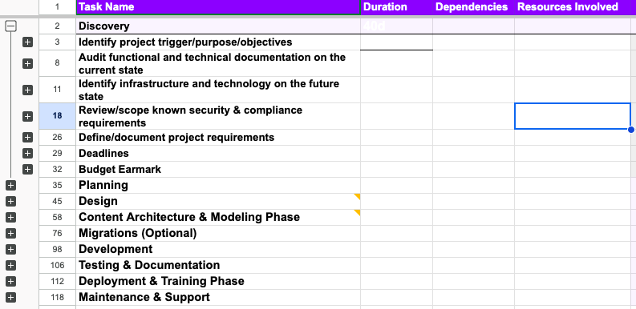

1. **Team Composition:** Identify the development team and upskill them regarding the tech stack being used. They should also start their Contentstack Academy courses (<https://www.contentstack.com/academy>), which are designed to equip them with best practices.

# **Types of migrations**

Based on the discovery process, migrations can be classified into two broad categories.

1. **Site Redesign:** The following activities must be completed while planning for migrations where the site is getting redesigned.
   1. A content audit should be completed.
   2. Designs should be approved.
   3. Content modeling must be completed and approved.
   4. Data has to be exported once Content modeling is completed. The data must be in Contentstack’s JSON-based format.
2. **Site Replatform:** The following is the list of activities that must be completed while planning for migrations where the site is being replatformed.
   1. A content audit should be completed.
   2. Data has to be exported in Contentstack’s JSON-based format.
   3. Content modeling is to be done as per best practices recommended by Contentstack.

# **Standard Processes**

1. Freeze content modeling.
2. Migrations always have to be done in an internal sandbox or non-production environment.
3. Sample migrated content has to be reviewed before the complete migration.
4. Integrate with the revised code base and test it thoroughly, along with all integrations. This testing must be done in a non-production environment to avoid any customer impact.
5. Defect fixes.
6. Create backups of the source data.
7. Go live for activities to be performed.